
Table of contents

Introduction 4
System Architecture 5
Overview 5
Infrastructure components 5
Data source server (10.130.25.152) 5
Client processing machine (10.130.25.158) 6
Local machine (ML Development) 6
PowerBI environment 7
Data flow 7
Scheduler 7
Storages 8
Bronze storage 8
Silver storage 9
Gold storage 11
OLAP database structure 13
Connection to SQL Server Management Studio 17
Machine Learning Training 21
Installation requirements 21
Libraries overview 21
Power consumption prediction 22
Data processing pipeline 22
Script location 25
Room occupancy prediction 25
Data processing pipeline 25
Script location 29
Dataflows 30
From Data sources to Bronze layer 30
From Bronze to Silver 33
From Silver to Gold 36
Generating machine learning predictions 38
Storing machine learning predictions 41
Automatization 44

Introduction
This project addresses the need for intelligent energy management and occupancy prediction in residential buildings. As apartments incorporate smart sensors and IoT devices, there emerges an opportunity to leverage this data. The primary challenge lies in collecting, processing, and analyzing diverse data streams from multiple apartments to generate insights and valuable information.
The system serves as a comprehensive data platform that centralizes, standardizes, and processes information from multiple disparate sources to create a unified view of apartment operations. Its primary purpose is to transform raw sensor data, reference information, and external weather data into a structured analytical foundation that supports decision-making for stakeholders. The solution establishes a reliable data pipeline for consistent data quality, proper integration between sources, and accessible reporting. While the platform does incorporate predictive capabilities for energy consumption and room occupancy, these represent just one application of the broader data infrastructure. The system's value lies in its ability to convert previously siloed operational data into an organized resource. By implementing a well-architected data solution with clear processing stages, the platform creates opportunities for both current analytical needs and future use cases that may emerge as the property management requirements evolve.
The solution is built on a technology stack centered around Python's data science ecosystem. Python serves as the primary programming language, giving the flexibility and extensive libraries necessary for both data engineering and machine learning tasks. For data extraction and pipeline orchestration, we implement custom Python scripts. The system operates on Windows Server environments, with scheduled tasks managed through Windows Task Scheduler for execution of data collection, processing, and prediction workflows.

System Architecture

Overview
The implemented solution follows a data engineering architecture pattern designed to handle multi-source data ingestion, processing, storage, and analysis. The system is distributed across three physical environments and implements a medallion architecture (Bronze/Silver/Gold) for data quality management. This approach guarantees data is progressively refined as it moves through the pipeline.

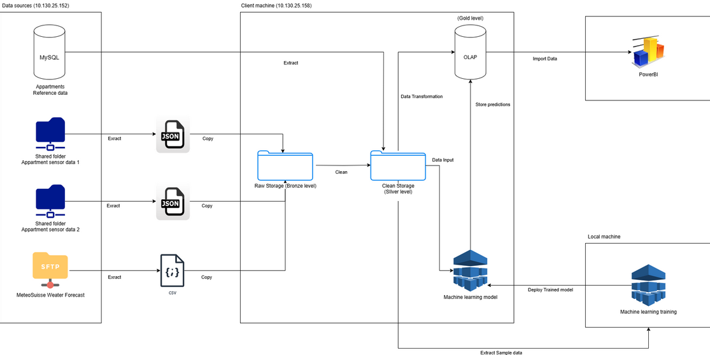

Infrastructure components

Data source server (10.130.25.152)
This server hosts the primary data sources for the system. A MySQL database that contains apartment reference data, including property specifications, location details, rooms information, list of the different sensors and devices registered in the apartments. The server connects via TCP/IP using standard MySQL connector protocols for data extraction.
The environment also includes two distinct shared network folders containing apartment sensor data. This information is stored in JSON format and accessed through SMB network share protocols. These repositories contain the core operational data from sensors deployed throughout the apartment buildings.
Additionally, an SFTP server hosts MeteoSuisse Weather Forecast data delivered in CSV format with scheduled updates. This external data source uses the SFTP protocol for data transfer.

Client processing machine (10.130.25.158)
This is the central processing that handles ETL operations and hosts the data storage layers. The data ingestion services implement extract processes for each data source type and manage copy operations to transfer data to raw storage. These processes are scheduled via task scheduler to maintain data timeliness.
The storage layers implement a medallion architecture with three distinct levels. Raw Storage (Bronze level) implements an immutable storage pattern that preserves the original data format and schema without validation or cleansing. This layer serves as a historical archive of source data, supporting reproducibility and auditability of all downstream processes.
Clean Storage (Silver level) implements data cleansing and standardization with schema enforcement and validation. This layer handles data structure changes, manages null values, and implements business rules for data quality.
OLAP Storage (Gold level) implements a dimensional model optimized for analytical query patterns. This layer integrates data from two sources, stores metrics and values alongside machine learning predictions. The Gold layer is specifically designed to support efficient business intelligence operations.
The machine learning models hosts the deployed ML models for inference, processing input data from the Silver layer and generating predictions that are stored in the Gold layer. A scheduled daily workflow creates continuous forecast generation.

Local machine (ML Development)
This environment is dedicated to machine learning development focused on two primary prediction tasks. For energy consumption forecasting, we develop two distinct models, one for each apartment, incorporating weather data from MeteoSuisse. Concurrently, we build four additional models to forecast room occupancy presence across four specific rooms (two rooms in each apartment), resulting in a total of six prediction models. We extract representative sample data from the silver layer, which provides cleaned inputs for all model training. After validation and comparative performance testing, only the best models are selected for deployment to the production machine.

PowerBI environment
The business intelligence and data visualization layer use OLAP storage. The visualization components provide interactive dashboards and reports that visualize both historical data and ML predictions.

Data flow
The ingestion flow begins with MySQL data extracted via SQL queries, JSON files extracted from shared folders, and CSV files copied from the SFTP server. All raw data is stored in the Bronze layer with minimal transformation, preserving the original content for future reference and reprocessing if needed.
The processing flow continues with Bronze to Silver transformation, where data cleaning operations are applied. The Silver to Gold transformation implements dimensional modeling and transformations. The Silver layer provides a data input feed to the ML model.
The machine learning flow involves training data extraction from the Silver layer to the local machine where model development occurs. After model training on the local machine, the trained models are deployed to the production environment. The production models performs inference on Silver data with predictions stored in the Gold layer for integration with business reporting.
The reporting flow culminates with PowerBI importing data from the Gold layer OLAP storage, which we use for visualization of both processed data and model predictions with data refresh scheduled based on requirements. The reporting environment provides the interface through which business value is ultimately delivered to end users.

Scheduler
The ETL process is implemented as a series of scheduled jobs that execute according to business requirements for data freshness. Incremental data loading is used to minimize processing and network traffic. Error handling and retry logic are incorporated to manage failures and keep operation going on.

Storages

Bronze storage
The Bronze storage layer is implemented as a hierarchical file system structure located at Documents > RawStorage > Data. This storage tier serves as the landing zone for all raw data coming from the various source systems before any transformation is applied. The organization of files within this storage follows a logical structure designed to maintain the original source data context and facilitate easy navigation.
Directory organization
The Bronze storage is organized into two primary subdirectories that reflect the distinct data sources in our architecture:
- Weather Data (/RawStorage/Data/Weather/) The Weather directory contains CSV files from MeteoSuisse weather forecasts. These files follow a consistent naming convention with the format Pred_YYYY-MM-DD.csv. The files are organized chronologically, providing a historical record of weather predictions.
- Sensors Data (/RawStorage/Data/Sensors/) The Sensors directory is further subdivided by apartment, with dedicated folders for Apartment_1 and Apartment_2. This separation allows for clear distinction between sensor readings from different residential units. Within each apartment folder, the data is organized in a year/month/day hierarchy (e.g., /Sensors/Apartment_1/2023/07/01/). At the daily level, sensor readings are stored as individual JSON files with a timestamp-based naming convention: DD.MM.YYYY HHMM_name_received.json. Each file contains a snapshot of sensor readings at a specific time, with multiple readings captured throughout the day at regular intervals. These files maintain the exact format received from the source systems, preserving all original data attributes and structures.
Storage characteristics
The Bronze storage implementation adheres to several key principles:
- Immutability: Once data is copied to the Bronze layer, it remains unchanged, preserving the source system's exact data representation. This immutability provides a historical record that can be referenced for auditing, troubleshooting, or reprocessing if needed.
- Completeness: All source data is stored in its entirety without filtering or transformation, ensuring no potentially valuable information is lost during the initial ingestion process.
- Source-Aligned structure: The directory organization mirrors the logical structure of the source systems, making it intuitive to locate specific data sets based on their origin and timeframe.
- File integrity: Each file maintains its original format (JSON for sensor data, CSV for weather data) and contains metadata such as modification dates to track when the data was ingested into the system.
The Bronze storage layer serves as the foundation of our data architecture, providing a complete repository of raw data that feeds into the subsequent Silver and Gold layers for further processing and analysis. This storage structure ensures that all downstream transformations and analytics can be traced back to their original source data, maintaining data lineage throughout the processing pipeline.

Silver storage
The Silver storage layer, labeled as "CleanStorage" in our architecture, is implemented at the path Documents > CleanStorage. This intermediate storage tier represents a advancement in data quality from the Bronze layer, containing cleansed data ready for analysis and model training. The structure maintains logical organization while implementing data quality improvements that prepare the information for downstream use.
Directory organization
The Silver storage maintains a structure similar to the Bronze layer:
- Primary data directory (/CleanStorage/Data/) The main data directory branches into the same two primary categories found in the Bronze layer:
  - Weather data (/CleanStorage/Data/Weather/) Weather data files maintain the same naming convention as in the Bronze layer (Pred_YYYY-MM-DD.csv), but the content has been cleansed and standardized. Each file contains weather forecast data that has undergone validation processes, geographic filtering for Sion and Visp locations, correction of anomalous values (replacing -99999 with zeros), and formatting consistency checks.
  - Sensors data (/CleanStorage/Data/Sensors/) The sensor data maintains the apartment-level separation (Apartment_1 and Apartment_2) and the temporal hierarchy (year/month/day). The file naming convention remains consistent with the Bronze layer, but the contents have been refined through data type normalization (especially for "Switch" fields), date/time standardization to consistent formats, and filtering of non-standard room categories.
- Logs directory (/CleanStorage/Logs/) The Silver layer introduces a Logs directory. This directory contains processing logs organized by data source category:
  - Sensors logs (/CleanStorage/Logs/Sensors/)
  - Weather logs (/CleanStorage/Logs/Weather/)
These logs use a standardized format with timestamp, log level, and component identifiers. They record comprehensive information about each ETL run, including configuration settings (source/destination directories, worker thread counts), processing status, and encountered issues. For instance, sensor logs track the source file discovery process, file counts, and processing warnings such as missing directories. This logging mechanism ensures full transparency and traceability across the data transformation pipeline.
Data quality enhancements
The Silver storage layer applies several key data quality enhancements to the raw data:
- Structural consistency: The data structures are normalized to ensure consistent data types (particularly boolean standardization), and formats across all files within each category.
- Data validation: Invalid or out-of-range values are identified and handled according to predefined business rules, such as replacing anomalous weather values (-99999) with zeros and filtering out devices from unrecognized room categories.
- Missing value management: The cleaning process addresses missing values through appropriate strategies such as imputation, flagging, or removal.
- Timestamp normalization: Temporal data is standardized to ensure consistent datetime formats (dates formatted as "dd/mm/yyyy" for sensor data and "dd-mm-yyyy" for weather data) and timezone handling, with time values extracted to dedicated "Hours" fields.
Operational characteristics
The Silver storage implementation operates with several distinct characteristics:
- Versioned transformation: While maintaining the same file organization as the Bronze layer, the Silver layer represents a versioned transformation of the data, with each file updated systematically as part of the ETL process.
- Selective persistence: Not all raw data fields may be carried forward to the Silver layer only attributes relevant to the analytical use cases are retained, with removed device data logged separately rather than included in the primary datasets.
- Schema enforcement: The Silver layer applies schema validation to ensure all data conforms to expected structures before being made available for analytical processes.
- Processing transparency: Through the Logs directory, the Silver layer maintains complete transparency about the transformations applied for data governance.
The cleansed and standardized datasets, from the Silver storage layer, provide the necessary quality for developing business intelligence and effective machine learning. While implementing significant quality improvements, this layer maintains clear lineage to the source data through consistent naming patterns and structural organization, creating a bridge between raw data acquisition and analytical applications.

Gold storage
The Gold layer of our architecture is implemented as a SQL Server database using a dimensional model optimized for analytical queries. Unlike the Bronze and Silver layers which use file-based storage, the Gold layer leverages a relational database management system (SQL Server Management Studio) to provide the structured query capabilities and performance necessary for business intelligence operations.
Database design philosophy
The database follows a star schema design pattern, which organizes data into fact tables surrounded by dimension tables. This approach was chosen for several key reasons:
- Storage optimization: The structure reduces data redundancy by separating descriptive attributes into dimension tables while keeping only metrics and foreign keys in fact tables.
- Data integrity: The relational model ensures referential integrity through foreign key constraints, preventing orphaned records and maintaining data consistency.
- Null value minimization: The schema design deliberately separates different sensor metrics into specialized fact tables to avoid sparse tables with numerous null values.
Dimension tables
The Gold layer includes seven dimensions tables that provide contextual information for the fact tables:
- DimDate: Temporal dimension for date values with year, month, and day attributes.
- DimTime: Temporal dimension for time values with hour and minute attributes.
- DimLocation: Geographic locations (primarily weather station sites).
- DimMeasurement: Types of measurements with their corresponding units.
- DimRoom: Room classifications within buildings.
- DimSensor: Types of sensors deployed throughout the apartments.
- DimBuilding: Building characteristics including location attributes, occupancy details, and heating status.
Fact tables
The database contains eight fact tables, each dedicated to a specific data domain:
- Fact_WeatherPrediction: Weather forecast data with measurements for specific locations.
- Fact_Plugs: Electrical plug data including power consumption, temperature, and switch state.
- Fact_Humidities: Humidity and temperature measurements from dedicated sensors.
- Fact_Motions: Motion detection data with associated light levels and temperature.
- Fact_MachineLearning: Machine learning prediction results for energy consumption and room occupancy.
- Fact_DoorsWindows: Status of doors and windows with battery levels and defense mode indicators.
- Fact_Consumptions: Detailed electrical consumption metrics including current, voltage, and power factors.
- Fact_Meteos: Environmental measurements such as CO2 levels, pressure, and noise.
Each fact table is designed with a composite primary key consisting of the relevant dimension keys (building, room, sensor, date, time), with additional measure columns specific to each domain. This specialization ensures that each fact table contains only the relevant metrics for its domain, avoiding the sparse tables that would result from a more generalized approach.
Data integration
The Gold layer serves as the integration point between operational sensor data and predictive analytics:
- Sensor data integration: Cleaned and standardized sensor data from the Silver layer is loaded into the appropriate fact tables based on sensor type and measurement category.
- Weather data integration: Processed weather prediction data is incorporated into the Fact_WeatherPrediction table for environmental context for energy consumption.
- Prediction storage: Machine learning model outputs are stored in the Fact_MachineLearning table, enabling comparison between predicted and actual values and supporting continuous model evaluation.
Technical implementation
The database implementation includes several technical considerations:
- Foreign key constraints: All fact tables maintain referential integrity through foreign key relationships to dimension tables, ensuring data consistency.
- Data types: Appropriate data types are selected for each column to optimize storage efficiency while maintaining necessary precision.
- Bit fields: Boolean values are stored as BIT data type for storage efficiency.
- Composite keys: Fact tables use composite primary keys rather than surrogate keys to eliminate the need for additional indexing and to directly support the dimensional model query patterns.
The Gold storage layer transforms cleaned data from the Silver layer into a structure optimized for business intelligence and predictive analytics integration. This dimensional model supports complex queries across various sensor types while maintaining performance and data integrity.

OLAP database structure
The Gold layer's SQL Server database uses a dimensional model with carefully designed attributes in each table. Below is a detailed breakdown of each table's attributes and their business significance.
Dimension tables
DimDate
- idDate: Primary key and identity column for date dimension
- year: Calendar year component (e.g., 2023, 2024)
- month: Month number (1-12)
- day: Day of month (1-31)
DimTime
- idTime: Primary key and identity column for time dimension
- hour: Hour component (0-23)
- minute: Minute component (0-59)
DimLocation
- idLocation: Primary key and identity column for location dimension
- siteName: Name of the weather station location (e.g., "Sion", "Visp")
DimMeasurement
- idMeasurement: Primary key and identity column for measurement types
- measurement: Type of measurement (e.g., "Temperature", "Humidity", "CO2")
- unit: Unit of measurement (e.g., "°C", "%")
DimRoom
- idRoom: Primary key and identity column for room classification
- roomName: Room name (e.g., "Bedroom", "Kitchen", "Livingroom")
DimSensor
- idSensor: Primary key and identity column for sensor types
- sensorType: Category of sensor (e.g., "Motion", "Plug", "Meteo")
DimBuilding
- idBuilding: Primary key and identity column for building information
- buildingType: Classification of building structure
- houseName: Identifier for the specific house
- latitude: Geographic coordinate
- longitude: Geographic coordinate
- adress: Street address of the building
- npa: Postal code
- city: City name
- nbPeople: Number of occupants
- isHeatingOn: Binary indicator of heating system status
Fact tables
Fact_WeatherPrediction
- idDate: Foreign key to DimDate for temporal context
- idTime: Foreign key to DimTime for time-of-day reference
- idMeasurement: Foreign key to DimMeasurement identifying the weather metric
- idLocation: Foreign key to DimLocation
- valueMeasurement: Numerical value of the weather prediction
Fact_Plugs
- idBuilding: Foreign key to DimBuilding for property context
- idRoom: Foreign key to DimRoom for spatial location
- idSensor: Foreign key to DimSensor for device identification
- idDate: Foreign key to DimDate for calendar reference
- idTime: Foreign key to DimTime for time component
- switch: Binary status of the plug (on/off)
- temperature: Device temperature reading
- overTemperature: Binary flag indicating excessive temperature
- counter1: First energy counter reading
- counter2: Second energy counter reading
- counter3: Third energy counter reading
- power: Current power consumption in watts
- overPower: Threshold for excessive power consumption
- timeplug: Duration of active plug usage
- total: Cumulative energy consumption
Fact_Humidities
- idBuilding: Foreign key to DimBuilding for property reference
- idRoom: Foreign key to DimRoom for spatial context
- idSensor: Foreign key to DimSensor for device identification
- idDate: Foreign key to DimDate for calendar reference
- idTime: Foreign key to DimTime for time component
- temperature: Ambient temperature reading
- humidity: Relative humidity percentage
- devicePower: Power level of the sensor device
Fact_Motions
- idBuilding: Foreign key to DimBuilding for property reference
- idRoom: Foreign key to DimRoom
- idSensor: Foreign key to DimSensor for device identification
- idDate: Foreign key to DimDate for calendar reference
- idTime: Foreign key to DimTime for time component
- motion: Binary indicator of detected movement
- light: Light level measurement at the sensor
- temperature: Ambient temperature at the motion sensor location
Fact_MachineLearning
- idDate: Foreign key to DimDate for prediction date
- idTime: Foreign key to DimTime for prediction time
- idBuilding: Foreign key to DimBuilding for property context
- idRoom: Foreign key to DimRoom for room-specific predictions
- ForecastDate: Target date for when the prediction was done
- ForecastType: Classification of prediction
- ForecastValue: Numerical prediction value
Fact_DoorsWindows
- idBuilding: Foreign key to DimBuilding for property reference
- idRoom: Foreign key to DimRoom for spatial context
- idSensor: Foreign key to DimSensor for device identification
- idDate: Foreign key to DimDate for calendar reference
- idTime: Foreign key to DimTime for time component
- doorsWindowsType: Classification of the monitored entry point
- battery: Battery level percentage of the sensor
- defense: Binary indicator of security
- switch: Binary status indicator
Fact_Consumptions
- idBuilding: Foreign key to DimBuilding for property reference
- idRoom: Foreign key to DimRoom for spatial context
- idSensor: Foreign key to DimSensor for device identification
- idDate: Foreign key to DimDate for calendar reference
- idTime: Foreign key to DimTime for time component
- isValid1: Data validity flag for first phase
- isValid2: Data validity flag for second phase
- isValid3: Data validity flag for third phase
- current1: Electric current measurement for first phase
- current2: Electric current measurement for second phase
- current3: Electric current measurement for third phase
- power1: Power consumption for first phase
- power2: Power consumption for second phase
- power3: Power consumption for third phase
- pf1: Power factor for first phase
- pf2: Power factor for second phase
- pf3: Power factor for third phase
- voltage1: Voltage measurement for first phase
- voltage2: Voltage measurement for second phase
- voltage3: Voltage measurement for third phase
- switch: Binary status of the main power switch
Fact_Meteos
- idBuilding: Foreign key to DimBuilding for property reference
- idRoom: Foreign key to DimRoom for spatial context
- idSensor: Foreign key to DimSensor for device identification
- idDate: Foreign key to DimDate for calendar reference
- idTime: Foreign key to DimTime for time component
- humidity: Relative humidity percentage measurement
- temperature: Ambient temperature
- co2: Carbon dioxide concentration
- batteryPercent: Battery level of the sensor device
- noise: Ambient noise level measurement
- pressure: Relative atmospheric pressure
- absolutePressure: Absolute atmospheric pressure measurement

Connection to SQL Server Management Studio
Usually, when you open the SQL Server Management Studio, the server name (the 2nd row on the “Server” section) should appear by default
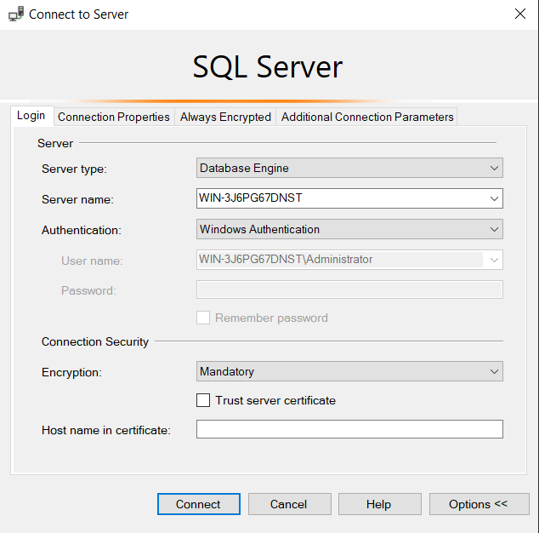
If the server name doesn't show up there are the steps you have to follow:
You have to press the down arrow on the server name and select “Browse more”
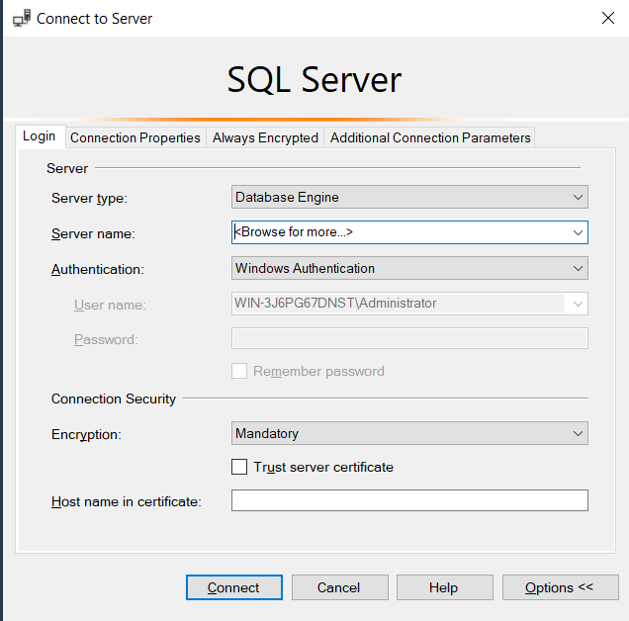
The ”Browse for Servers” windows will show up and there you have to click on the “+“ near the “Database engine“.
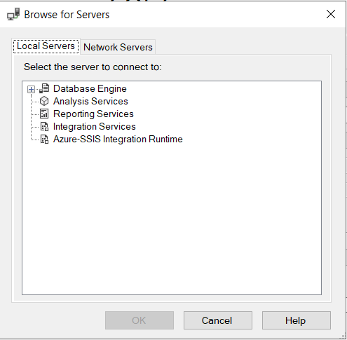
On the “Local Servers” tab you have to double click on the option named “WIN-3J6PG67DNST”.
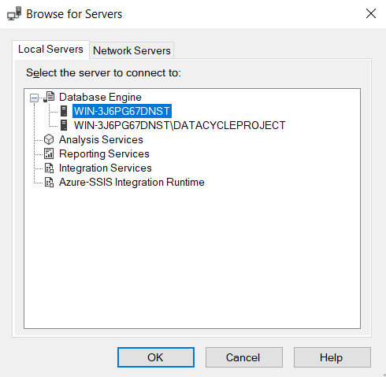
After you chose the server, the last thing to do is to check the “Trust server certificate” box and click on “Connect”.
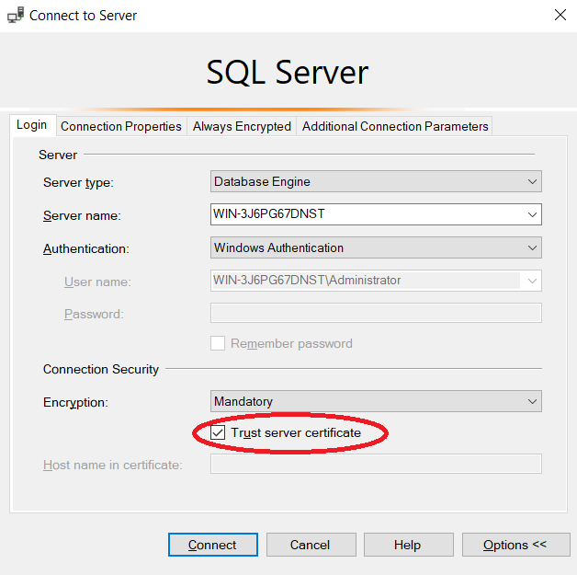

Machine Learning Training
This section describes a machine learning system that predicts room occupancy and power consumption. The system analyzes sensor data collected from May 24 to September 21, 2023. The prediction system consists of two components:
Power consumption prediction: Analyzes energy usage patterns alongside weather data to forecast future electricity consumption based on time of day, day of week, and environmental conditions.
Room occupancy prediction: Uses motion sensor data, temperature, and light levels to determine when specific rooms are occupied, transforming intermittent motion signals into continuous presence predictions.
Both systems follow similar methodologies, from data extraction and cleaning through feature engineering to model training, implementing Random Forest, XGBoost, and SARIMAX modeling approaches.

Installation requirements
To run both prediction systems, the following Python packages need to be installed through pip: pandas, numpy, matplotlib, seaborn, scipy, scikit-learn, xgboost, statsmodels, missingno, pickle

Libraries overview
This project utilizes a set of data science and machine learning libraries to process power consumption data and create models:
Pandas and NumPy: Core data manipulation libraries for structured data handling, statistical computations, and numerical operations.
Matplotlib and Seaborn: Visualization libraries that provide complementary approaches to creating informative plots of time series, correlations, and feature distributions.
SciPy: Used for advanced statistical testing.
Scikit-learn: Provides robust implementations of various machine learning algorithms, preprocessing tools, and evaluation metrics.
XGBoost: Gradient boosting framework that implements machine learning algorithms under the gradient boosting framework, utilized for regression tasks.
statsmodels: Offers statistical models and time series analysis tools, particularly the SARIMAX model for time series forecasting.
missingno: Specialized library for visualizing missing data patterns.
Pickle: Used for model serialization and storage.

Power consumption prediction

Data processing pipeline
The power consumption prediction system follows a workflow that includes data extraction, cleaning, feature engineering, model training, and evaluation. Below is a detailed description of each component:
1. Data extraction and combination
We begin by extracting consumption data from JSON files containing power consumption records for different apartments. The functions include:
extract_consumption_data(): Extracts relevant fields from JSON, including timestamps, consumption values, and apartment identifiers.
process_consumption_data(): Processes all JSON files for specified time periods and apartments, creating daily consumption CSV files.
combine_room_data(): Aggregates daily data into consolidated room-specific files for analysis.
These functions handle nested JSON data structures, extract temporal features (day of week, weekends), and organize the data into a structured format for subsequent analysis.

2. Data quality assessment and cleaning
In this part, we implement data quality checks and cleaning procedures:
check_duplicates(): Identifies exact duplicates and time-based duplicates in the dataset.
check_missing_values(): Analyzes missing data patterns and quantifies the extent of missingness in each column.
check_outliers(): Uses the Interquartile Range (IQR) method to detect statistical outliers in numerical columns.
remove_rows_with_missing_values(): Removes or keeps rows based on a configurable threshold of missing values.
remove_duplicates(): Eliminates duplicate records with priority given to the first occurrence.
handle_outliers(): Implements various strategies for outlier treatment, including capping, removing, or applying statistical transformations.
clean_data(): Orchestrates the entire cleaning workflow, applying all cleaning functions sequentially.
The data cleaning process is designed to be modular and configurable to test different treatment strategies based on the specific characteristics of the dataset.

3. Feature engineering and augmentation
We add additional features to the base dataset to improve model performance:
clean_apartment_data(): Selects only relevant columns for analysis, reducing dimensionality.
aggregate_hourly_data(): Transforms minute-level data into hourly aggregations to reduce noise and capture broader patterns.
add_weather_data(): Integrates external weather data (temperature, humidity, rainfall, radiation) as predictive features.
engineer_apartment_features(): Creates advanced features including:
- Seasonal indicators (Winter, Spring, Summer, Fall)
- Lag features (1-hour and 3-hour historical consumption)
- Lead features (future consumption values, for training purposes)
- Rolling window statistics (3-hour and 6-hour moving averages)
The feature engineering process is particularly sophisticated in creating temporal context through lag and rolling features, which help capture the nature of power consumption patterns.

4. Data visualization and exploratory analysis
We include extensive visualizations to help understand consumption patterns:
- Hourly pattern visualization showing average consumption by hour of day
- Daily time series visualization of consumption and weather variables
- Weekly pattern visualization to highlight weekday vs. weekend differences
- Correlation heatmaps between consumption and weather variables
Additionally, the system conducts stationarity tests using the Augmented Dickey-Fuller test and performs time series decomposition to identify trend, seasonal components.

5. Model training and evaluation
The system implements three different modeling approaches for power consumption prediction:
Random forest regressor
- Ensemble-based approach with tuned hyperparameters
- Handles non-linear relationships between features and target
- Provides feature importance rankings to understand predictive drivers
XGBoost regressor
- Gradient boosting approach with regularization to prevent overfitting
- Optimized through early stopping based on validation performance
- Advanced feature importance metrics based on gain contribution
SARIMAX Time Series model
- Combines autoregressive components with exogenous weather and time variables
- Captures both seasonal patterns and trend components
- Implements differencing to handle non-stationarity
Each model is evaluated using multiple performance metrics:
- Mean Absolute Error (MAE)
- Root Mean Squared Error (RMSE)
- Mean Absolute Percentage Error (MAPE)
- R² Score
The system uses a chronological train-test split to simulate real-world prediction scenarios, with the most recent 20% of data reserved for testing.

6. Model persistence
Trained models are serialized and saved using Python's Pickle library:
- random_forest_power_consumption_app1.pkl
- random_forest_power_consumption_app2.pkl
- xgboost_power_consumption_app1.pkl
- xgboost_power_consumption_app2.pkl
- sarimax_power_consumption_app1.pkl
- sarimax_power_consumption_app2.pkl

Script location
The script can be found in the main branch of our repository in the folder Scripts/MachineLearning/Training :

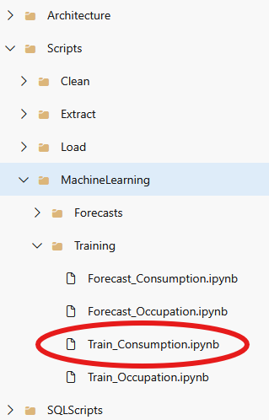

Room occupancy prediction

Data processing pipeline
The room presence prediction system follows a workflow that includes data extraction, cleaning, feature engineering, model training, and evaluation. Below is a detailed description of each component:

1. Data extraction and combination
We begin by processing motion sensor data from multiple apartments and rooms:
extract_motion_data(): Extracts motion data from JSON files, including motion status, temperature, and light readings.
process_motion_data(): Processes all JSON files for specified time periods and apartments, creating daily motion CSV files.
combine_room_data(): Aggregates daily data into consolidated room-specific files for analysis.
These functions handle nested data structures while preserving temporal information and sensor readings. The system organizes data hierarchically by apartment and room, making it easier to analyze occupancy.

2. Data quality assessment and cleaning
In this section, we implement data quality checks and cleaning procedures:
check_duplicates(): Identifies exact duplicates and time-based duplicates.
check_missing_values(): Quantifies the extent of missing data across different sensors and time periods.
check_outliers(): Uses the Interquartile Range (IQR) method to detect statistical outliers in numerical variables like temperature and light readings.
remove_rows_with_missing_values(): Eliminates or keeps rows based on configurable thresholds of missing data.
remove_duplicates(): Removes duplicate records with a preference for preserving the first occurrence.
handle_outliers(): Implements multiple strategies for outlier treatment, including capping extreme values and statistical transformations.
clean_data(): Orchestrates the entire cleaning workflow, applying all functions sequentially for each dataset.
The cleaning process employs statistical techniques to identify and handle anomalies while preserving the temporal integrity of the sensor data.

3. Data visualization and exploration
We include visualizations to explore occupancy patterns:
- Histograms of motion detection status, light levels, and temperature readings
- Box plots showing the distribution of sensor readings across different rooms
- Time series plots revealing daily and weekly occupancy patterns
- Correlation analysis between motion events, presence percentage, and environmental factors
These visualizations provide insights into occupancy behaviors, temporal patterns that inform model selection and feature engineering.

4. Feature engineering and data transformation
process_columns(): Restructures the dataset by extracting minute information from timestamps and removing redundant columns.
create_presence_features(): Creates lagged and lead features to capture historical and future motion states.
label_presence(): Develops a sophisticated occupancy label by analyzing motion patterns over time, filling in gaps where presence is likely but motion wasn't detected.
aggregate_presence_to_hourly(): Transforms minute-level data to hourly aggregations with comprehensive statistics.
This step is particularly important. Rather than treating motion detection events as direct occupancy indicators, we use a temporal context window to infer continuous presence from intermittent motion signals. This addresses the common limitation where occupants may be present but not moving enough to trigger motion sensors. This will be essentially our target variable.

5. Time series analysis
We perform time series analysis to know if our data is statically stable:
test_stationarity(): Evaluates whether occupancy data exhibits stationarity using the Augmented Dickey-Fuller test.
decompose_series(): Decomposes time series data into trend, seasonal, and residual components.
analyze_room_presence(): Conducts comprehensive time series analysis for each room's occupancy patterns.
These analyses reveal the presence of daily and weekly seasonality in occupancy patterns, informing the structure of time series models.

6. Model training and evaluation
The system implements three different modeling approaches for occupancy prediction:
Random forest regressor
- Ensemble-based approach that captures non-linear relationships between environmental factors and occupancy
- Provides feature importance rankings that highlight the most predictive variables
XGBoost regressor
- Gradient boosting approach with regularization to prevent overfitting
- Optimized through early stopping based on validation performance
- Captures complex interactions between time features and sensor readings
SARIMAX Time Series model
- Combines autoregressive components with seasonal patterns
- Capable of modeling the inherent temporal structure of occupancy data
- Effective for forecasting future occupancy based on historical patterns alone
Each model is evaluated using multiple performance metrics:
- Mean Absolute Error (MAE)
- Root Mean Squared Error (RMSE)
- Modified Mean Absolute Percentage Error (MAPE) that handles zero values appropriately
- R² Score
The system uses a chronological train-test split to simulate real-world prediction scenarios, with the most recent 20% of data reserved for testing.

7. Model persistence
Trained models are serialized and saved using Python's Pickle library:
- rf_apartment1_kitchen.pkl, rf_apartment1_office.pkl, etc. for Random Forest models
- xgb_apartment1_kitchen.pkl, xgb_apartment1_office.pkl, etc. for XGBoost models
- sarima_apartment1_kitchen.pkl, sarima_apartment1_office.pkl, etc. for SARIMAX models

Script location
The script can be found in the main branch of our repository in the folder Scripts/MachineLearning/Training :

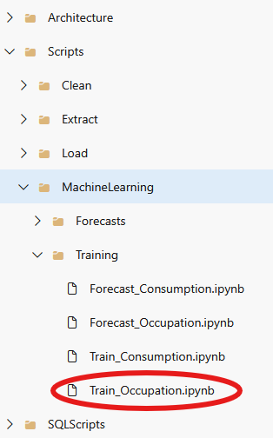

Dataflows

From Data sources to Bronze layer
The data acquisition layer of our architecture employs a multi-threaded approach to collect data from external sources and store it in the Bronze layer (Raw Storage). This first step in our data pipeline is implemented through Python scripts that handle different data sources with appropriate security and efficiency considerations.
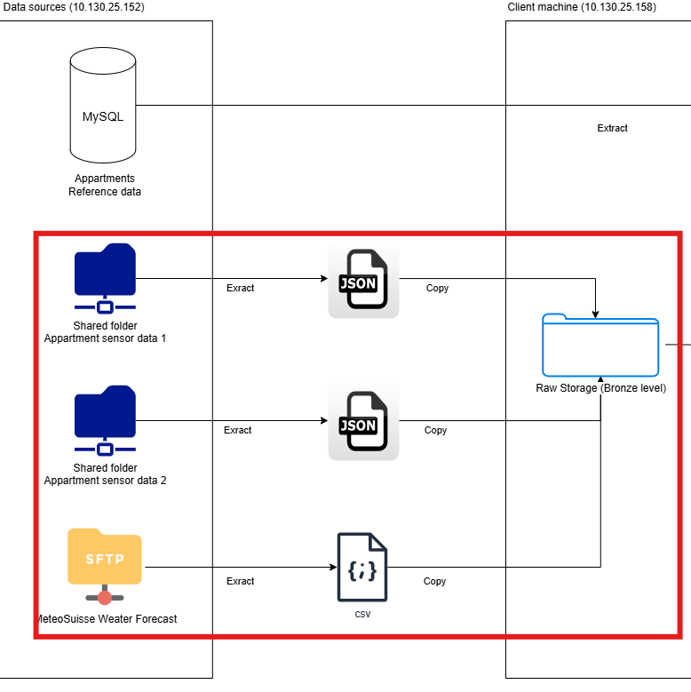
The acquisition scripts are located in the Documents > RawStorage > Scripts directory on the client environment and are stored in the Scripts/Extract repository folder in our Azure DevOps project.
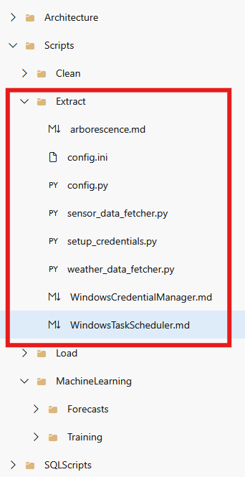
Credential management
To not have the connection credentials in plain text while allowing automated access to data sources, the system implements a credential management approach:
- Windows credential manager: Sensitive connection details are stored in the Windows Credential Manager rather than in configuration files or environment variables.
- Credential setup utility: A dedicated setup_credentials.py script provides an CLI for administrators to store connection parameters including:
  - Remote host information
  - SMB share details
  - Username and password credentials
- Retrieval: The CredManager class in config.py provides programmatic access to these credentials through the Windows API.
Configuration management
The system employs a hybrid configuration approach using both files and secure credential storage:
- Configuration file: Non-sensitive settings are stored in a config.ini file, including:
  - Data root directory paths
  - Worker thread configuration
  - Processing parameters
- Dynamic configuration loading: The Config class centralizes all configuration settings, loading both the file-based and credential-based parameters at runtime.
- Validation: Configuration validation ensures all required parameters are present before operations begin.
Weather data acquisition
The weather_data_fetcher.py script implements the following workflow:
- SFTP Connection: Establishes a secure connection to the MeteoSuisse server using Paramiko's SFTP implementation.
- Multi-threading: Utilizes a thread pool to parallelize downloads, with each thread:
  - Creating its own SFTP session
  - Navigating to the /Meteo2 remote directory
  - Processing files from a shared queue
- Incremental processing: Files are only downloaded if they don't already exist in the local storage, preventing redundant transfers.
- File filtering: Only prediction files (starting with "Pred_" and ending with ".csv") are downloaded.
- Organized storage: Downloaded files are stored directly in the Weather directory within the Raw Storage layer.
Sensor Data Acquisition
The sensor_data_fetcher.py script handles the more complex apartment sensor data with these features:
- SMB Protocol: Connects to network shares using the SMB protocol via the pysmb library
- Robust connection handling: Implements fallback logic to handle UNC path parsing and share discovery if the initial connection fails.
- Apartment detection: Identifies which apartment a file belongs to based on naming patterns, directing it to the appropriate directory.
- Date-based organization: Extracts date information from filenames to create a year/month/day folder hierarchy.
- Multi-threaded downloads: Employs multiple worker threads to process files concurrently, each with its own SMB connection.
- Skip logic: Avoids reprocessing files that have already been downloaded.
Error handling and logging
Both data acquisition scripts implement comprehensive error handling and logging:
- Thread-specific logging: Each thread logs its activities with its thread ID for better traceability
- Exception management: Try-except blocks capture and log exceptions at multiple levels without terminating the entire process
- Status reporting: Detailed success/failure statistics are reported at the end of each run
- Connection error recovery: Scripts attempt to recover from various connection failures through retry mechanisms and alternative approaches

From Bronze to Silver
The data cleaning process is responsible for processing raw data from the Bronze layer (Raw Storage) into the cleaned Silver layer (Clean Storage).

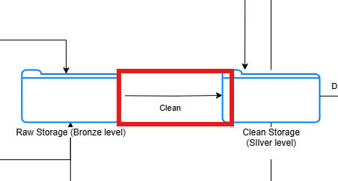

This component of the data pipeline is implemented through Python scripts located in the Documents > CleanStorage > Scripts directory on the client environment, and stored in the Scripts/Clean repository folder in our Azure DevOps project.
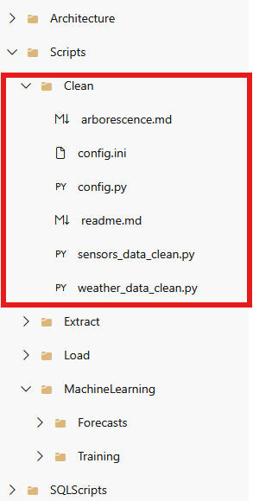

Configuration management
The transformation scripts implement a simplified configuration approach compared to the acquisition layer. A dedicated config.ini file contains all necessary paths and processing parameters, including raw and clean data paths for both sensor and weather data, as well as log directory locations. Worker configuration parameters control the number of concurrent processing threads with both sensor and weather processing set to use 4 parallel threads. The central Config class in config.py handles loading, validation, and access to configuration parameters through a class-based approach.
Sensor data transformation
The sensors_data_clean.py script implements data quality enhancements. The convert_keys() function implements field name standardization by converting all keys to PascalCase for consistent naming and providing special handling for "Switch" fields, transforming text values ("on"/"off") to Boolean values. Date standardization is managed by the process_dates() function, which normalizes temporal information by handling multiple date formats in "Datetime" fields, processing Unix timestamps in "TimePlug" and "TimeConsumption" fields, converting all dates to standard "dd/mm/yyyy" format, and extracting time components to "Hours" field in "HH" format.
The script also implements data filtering through the remove_device_entries() function, which compares device locations against a predefined list of valid rooms, removes non-standard device entries while preserving them in separate log files, and processes nested structures with special handling for "Meteos" category. Directory structure is maintained by the process_file() function, which determines apartment designation based on filename patterns, extracts date components for year/month/day directory structure, and creates the necessary directory tree before saving processed files.
Weather data transformation
The weather_data_clean.py script implements transformations for CSV-based weather data. Data validation is performed by the validate_dataframe() function, which verifies source data quality by checking for required columns ('Time', 'Value', 'Prediction', 'Site', 'Measurement', 'Unit') and validating the absence of null values in fields. Geographic filtering is implemented by the process_file() function, which selects only data for Sion and Visp locations and logs row counts before and after filtering.
The script also implements specific data quality improvements, including replacing anomalous values (-99999) with zeros, processing timestamps to split date and time components, and converting date format to 'dd-mm-yyyy'. Output handling is managed through dedicated processing logic that detects and reports empty result sets after filtering and produces detailed processing metrics for monitoring.
Multi-threading implementation
Both transformation scripts implement thread-based parallel processing using the ThreadPoolExecutor to manage concurrent file processing. Thread safety is maintained by tracking thread-specific identifiers for logging and diagnostics, and thread count is configurable via the SENSOR_MAX_WORKERS and WEATHER_MAX_WORKERS parameters.
Logging system
A logging framework captures detailed operation information. Logger configuration uses UTF-8 encoding to handle special characters in data. Execution metrics are collected for each processing run, including file counts, success rates, processing times, and row transformations. Thread tracking monitors the number of active threads to verify execution parallelism.
The transformation layer maintains the same basic structure as the Bronze layer while improving data quality through standardization, validation, and filtering.

From Silver to Gold
The Silver to Gold transformation layer represents the final stage of our data processing pipeline, where cleaned and standardized data from the Silver layer is loaded into the structured SQL Server database (Gold layer).
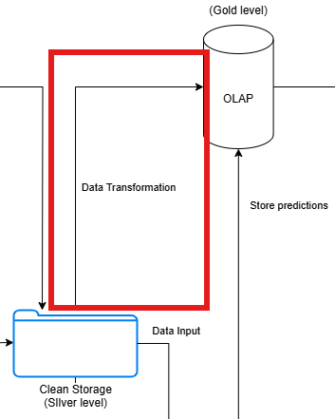

This component is implemented through Python scripts located in the Documents > GoldStorage > Scripts directory on the client environment, and stored in Scripts/Load repository folder in our Azure DevOps project.
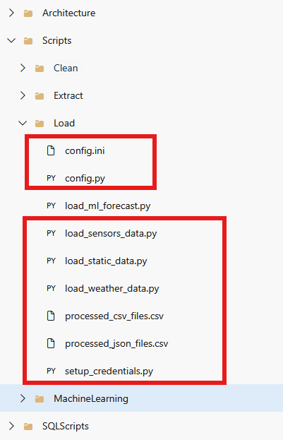

Configuration management
The Gold layer scripts implement a configuration approach that manages database connection details. The configuration system uses a hybrid approach combining file-based settings with credential storage. A config.ini file contains non-sensitive directory paths and processing parameters. Database connection details are stored in Windows Credential Manager, including server name, database name, and authentication credentials. The setup_credentials.py script provides a CLI interface to configure database access parameters.
Database connection management
All scripts implement a standardized database connection approach. Database connections are established through a connection string that uses Windows authentication. For multi-threaded scripts, thread-local storage guarantees each thread maintains its own database connection.
Reference data loading
The load_static_data.py script handles the initial loading of reference data. Building classification data is loaded into memory as a reference dictionary. Apartment information is populated into the DimBuilding table with data. Standard room types are loaded into the DimRoom table with normalization of naming conventions (e.g., correcting "Bdroom" to "Bedroom"). Sensor type definitions are inserted into the DimSensor table, establishing the taxonomy for sensor data. This script is only run one time to load the reference data and is not part of the scripts launched daily.
Sensor data integration
The load_sensors_data.py script handles the transfer of sensor data from JSON files to fact tables. The script implements "get-or-create" logic for dimension records, including date and time dimensions from temporal data, building identification from metadata, room classification based on standardized names, and sensor type categorization. Boolean fields are properly converted to BIT values for SQL Server storage.
The script uses a thread pool to process files concurrently, with each thread maintaining a separate database connection. The processing stages include loading plugs data into Fact_Plugs with power consumption metrics, recording doors/windows status in Fact_DoorsWindows, storing motion detection information in Fact_Motions, inserting environmental readings into Fact_Meteos, loading humidity measurements into Fact_Humidities, and storing detailed consumption data in Fact_Consumptions. A CSV-based log tracks processed files to enable incremental loading.
Weather data integration
The load_weather_data.py script handles meteorological data integration. Weather measurements are standardized using a predefined mapping dictionary. Forecast dates are extracted from filenames using regular expressions. Data for relevant locations (Sion, Visp) is identified and properly integrated.
The script sorts files chronologically and only processes newer files if older ones have already been processed. Existing forecasts for the same date range are deleted before loading new data to prevent duplication.
Error handling and logging
All Gold layer scripts implement error handling. Database connection issues are captured and reported with error messages. Required attributes are verified before database operations. SQL operations are wrapped in appropriate transaction boundaries to ensure data integrity. Detailed metrics are output during processing, including record counts and operation durations.
The Gold layer transform scripts complete the data pipeline, converting the standardized data from the Silver layer into a dimensional model optimized for analytical query patterns.

Generating machine learning predictions
The machine learning prediction generation component transforms historical data into forecasts.

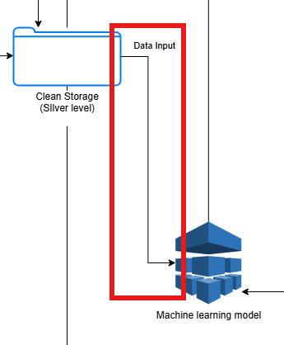

This functionality is implemented through Python scripts located in the Documents > MachineLearning directory on the client environment, and stored in the Scripts/MachineLearning/Forecasts repository folder in our Azure DevOps project.
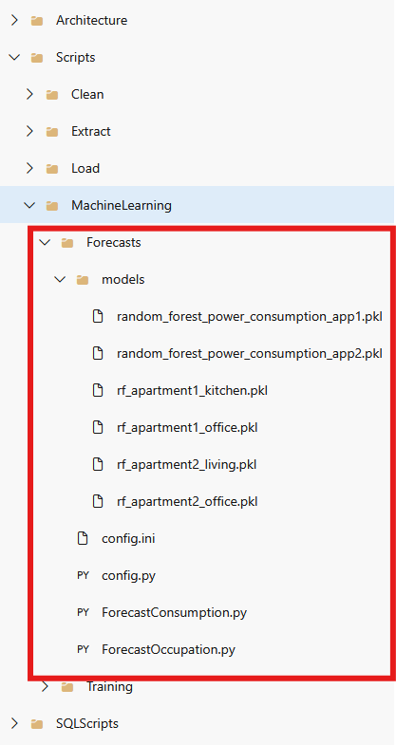

Configuration management
The forecasting scripts utilize a simplified configuration approach by loading path settings from a shared configuration file. A config.ini file specifies the paths to the required data sources, while the Config class in config.py handles loading and validating these settings. This configuration verifies that the scripts can locate the necessary Silver layer data for generating predictions.
Energy consumption forecasting
The ForecastConsumption.py script implements a pipeline for predicting apartment energy usage:
Data extraction involves retrieving the most recent sensor data available (typically 2 weeks) from the Silver layer. The script identifies appropriate date ranges and apartment designations, extracting consumption-related metrics for each apartment.
Data preprocessing applies quality improvement operations including removing missing values, eliminating duplicates, and handling outliers. The script implements these corrections to ensure reliable data before the forecasting stage.
Feature engineering enhances the raw data with valuable derived attributes including temporal features (hour, day of week, weekend indicators), seasonal components (based on month), lag variables (from previous hours/days), and rolling window calculations (3-hour and 6-hour averages).
The script integrates weather data from the Silver layer using location-specific mappings for Sion, incorporating temperature, humidity, precipitation, and solar radiation measurements.
The forecasting process loads pre-trained models from the models directory and generates 72-hour predictions (3 days) of hour-by-hour consumption. These forecasts are saved to standardized CSV files that can be integrated with the Gold layer.
Room occupancy prediction
The ForecastOccupation.py script provides functionality for predicting room-specific occupancy patterns. Similar to the energy forecasting, the occupancy prediction follows a structured approach:
Motion data extraction retrieves recent sensor measurements from specific rooms in each apartment, focusing on presence detection signals and environmental context (temperature, light levels).
Data cleansing applies standardized quality improvements by removing invalid readings, eliminating duplicate entries, and addressing outliers in the sensor data.
The occupancy determination process uses a algorithm that considers both direct motion detection and contextual patterns between readings to infer continuous presence even during brief detection gaps.
Feature engineering creates presence-specific metrics including the percentage of time each room is occupied during hourly blocks, along with motion intensity indicators that reflect activity levels.
The forecasting component uses pre-trained models for each specific room to generate 3-day hourly occupancy predictions based on historical patterns and temporal factors.
Prediction output
Both prediction scripts generate standardized output files with consistent structure:
The energy consumption forecast files (Apartment_1_power_consumption_forecast.csv and Apartment_2_power_consumption_forecast.csv) contain hourly predictions of total power consumption for a 3-day horizon.
The room occupancy forecast files (Apartment_1_Kitchen_motion_forecast.csv, Apartment_1_Office_motion_forecast.csv, etc.) contain hourly predictions of room presence for each tracked room.
All forecast files include a Forecast_Date column to track when predictions were generated.
The machine learning prediction scripts complete the analytical capabilities of our data pipeline, transforming the cleansed historical data into forward-looking predictions that support energy optimization and space utilization planning.

Storing machine learning predictions
The prediction storage layer represents the final step in our machine learning pipeline, transferring forecast data from prediction files into the structured SQL Server database.

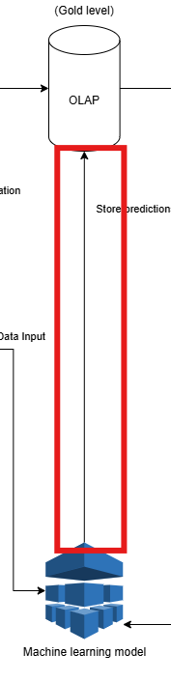
This component is implemented through the load_ml_forecast.py script located in the Documents > GoldStorage > Scripts directory on the client environment and stored in the Scripts/Load repository folder in our Azure DevOps project.

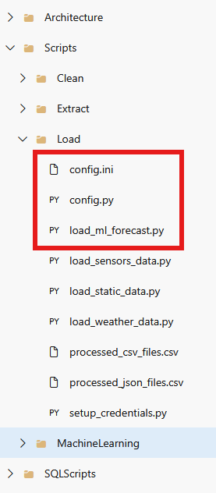

Configuration management
The script leverages the same configuration approach as other Gold layer components. The configuration system uses a hybrid approach combining file-based settings with secure credential storage. A config.ini file contains the necessary paths, including a dedicated ML_FORECASTS_DIR that specifies where prediction files are stored. Database connection details are managed through Windows Credential Manager, maintaining separation between configuration paths and authentication information.
Database connection
The script establishes connectivity to the SQL Server database using a standardized connection approach with integrated Windows authentication. This connection is used throughout the script to interact with the database's dimension and fact tables.
Prediction file processing
The script systematically processes machine learning prediction files through several key stages. File discovery scans the ML_FORECASTS_DIR directory to identify all CSV files ending with _forecast.csv, which is the standard naming convention for both energy consumption and room occupancy predictions.
Information extraction parses filenames through regular expression patterns to identify apartment identifier (Apartment_1 or Apartment_2), room name (Kitchen, Office, Living, House), and forecast type (power_consumption or motion).
Mapping implementation converts internal identifiers to their database equivalents, with forecast types translated to labels ("Room presence" and "Power consumption") and apartment identifiers mapped to owner names.
Dimension lookup retrieves dimension key values for entity relationships, obtaining date IDs, time IDs, building IDs, and room IDs from their respective dimension tables.
Data integration
The prediction data is inserted into the Fact_MachineLearning table with error handling and transaction management. Duplicate management checks for existing records with matching dimension keys and forecast dates, implementing an upsert pattern where existing records are updated with new forecast values and missing records are inserted as new entries.
Value handling identifies the appropriate value column based on forecast type, using "Predicted_Presence" for room occupancy forecasts and "TotalPower_Sum" for energy consumption forecasts.
Transaction control manages database operations within explicit transaction boundaries, with commits occurring every 50 rows to prevent large transaction logs and rollbacks applied on error to maintain data integrity.
Error handling
The script implements error management. File-level protection processes each file in its own try-except block to prevent individual file failures from affecting the entire batch.
Row-level recovery captures and logs errors without interrupting the processing of subsequent rows. Detailed logging provides verbose output about processing stages, warning about missing dimension entries, and capturing both row-level and file-level exceptions.
Resource cleanup ensures database connections are properly closed even when exceptions occur, preventing resource leaks.

Automatization
The data pipeline's operational reliability is done through tasks automation implemented using Windows Task Scheduler. This automation orchestrates the entire data flow across all layers, from initial data collection to predictive analytics and database loading.
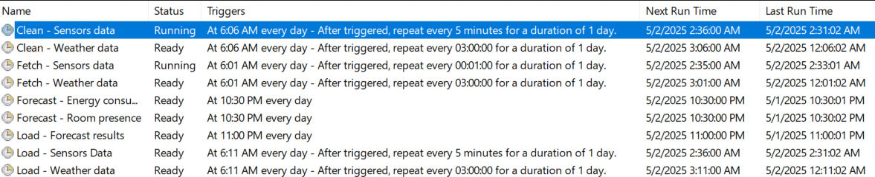

Task scheduler configuration
The automation system consists of nine distinct scheduled tasks, each responsible for a specific component of the data pipeline. All tasks share common configuration characteristics. Tasks run whether a user is logged on or not for continuous operation even during periods without active user sessions.
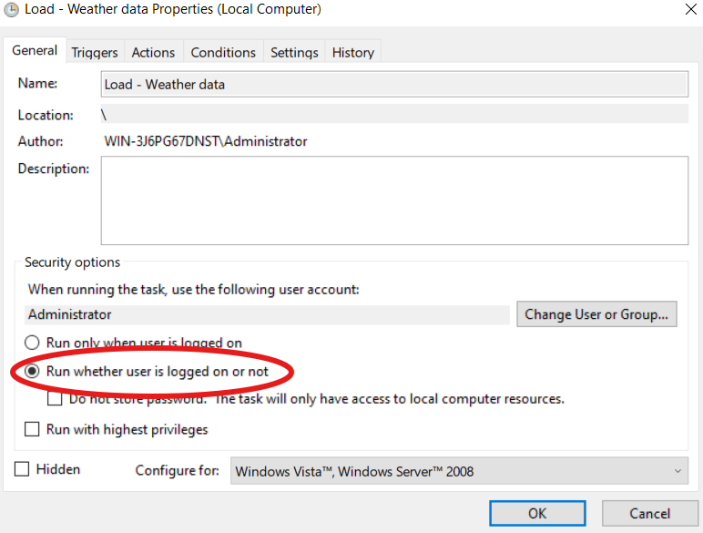
History logging is enabled for all tasks, facilitating monitoring and troubleshooting. Finally, tasks are configured with appropriate timeout and retry settings to maintain resilience.
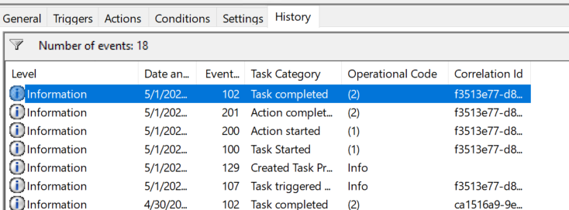

Task scheduler pattern
Our task scheduling uses staggered start times with intervals (5 minutes for sensors, 3 hours for weather) because tasks won't launch if the previous instance is still running, making very frequent scheduling unnecessary. The 5-minute interval provides adequate time for task completion while maintaining data freshness. This approach prevents excessive resource consumption on the virtual machine while the multi-threaded design within each script already optimizes individual task performance. This balanced approach guarantees continuous data flow while preserving system stability.
- Data acquisition (6:01 AM)
  - Fetch - Sensors data: Runs at 6:01 AM daily with 1-minute repeat frequency
  - Fetch - Weather data: Runs at 6:01 AM daily with 3-hour repeat frequency
- Data cleaning (6:06 AM)
  - Clean - Sensors data: Runs at 6:06 AM daily with 5-minute repeat frequency
  - Clean - Weather data: Runs at 6:06 AM daily with 3-hour repeat frequency
- Data loading (6:11 AM)
  - Load - Sensors Data: Runs at 6:11 AM daily with 5-minute repeat frequency
  - Load - Weather data: Runs at 6:11 AM daily with 3-hour repeat frequency
- Predictions (10:30 PM)
  - Forecast - Energy consumption: Runs at 10:30 PM daily
  - Forecast - Room presence: Runs at 10:30 PM daily
- Prediction integration (11:00 PM)
  - Load - Forecast results: Runs at 11:00 PM daily
For tasks requiring multiple executions throughout the day, we configure recurring schedules through the Task Scheduler interface. The process involves accessing the task properties, selecting the "Triggers" tab, and clicking "Edit" on the existing trigger.
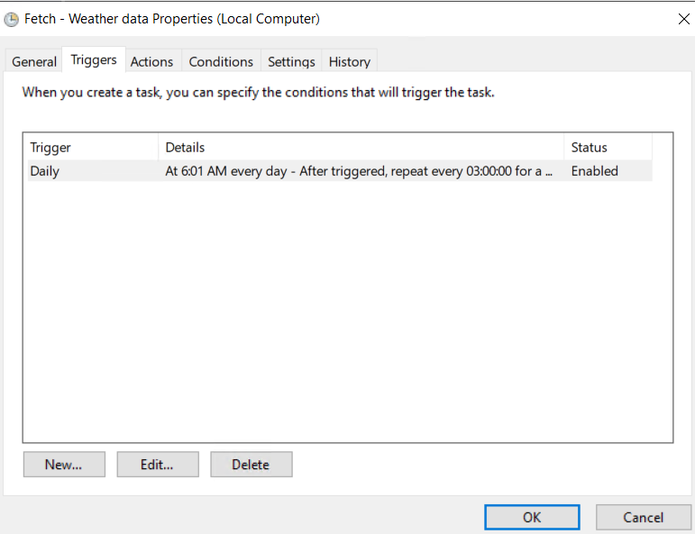
In the "Edit Trigger" dialog, we set the task to run "Daily" with a specific start time (such as 6:01 AM for data fetching or 6:11 AM for data loading). Under "Advanced settings," we check the "Repeat task every" option and specify the appropriate interval (3 hours for weather data, 5 minutes for sensor data) along with a duration setting of "1 day" to maintain the repetition pattern throughout the operating period.
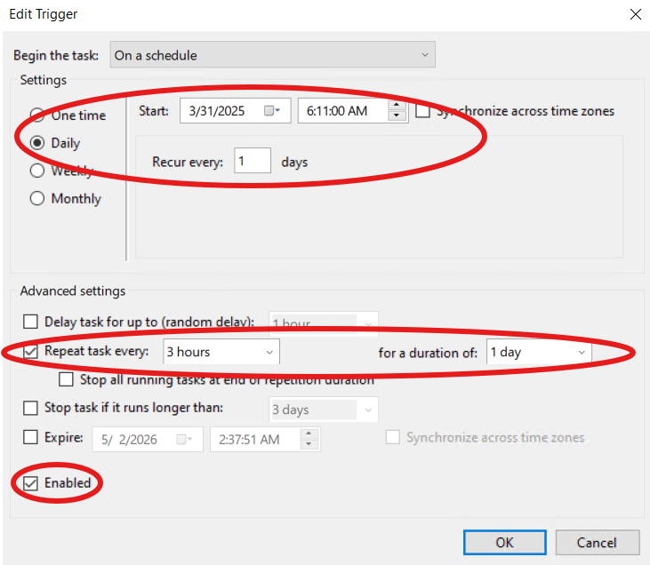
Task execution environment
Each task executes a specific Python script using the system's Python 3.13 interpreter. The execution paths are configured as follows:
- Data acquisition scripts:
  - C:\Users\Administrator\Documents\RawStorage\Scripts\sensors_data_fetcher.py
  - C:\Users\Administrator\Documents\RawStorage\Scripts\weather_data_fetcher.py
- Data cleaning scripts:
  - C:\Users\Administrator\Documents\CleanStorage\Scripts\sensors_data_clean.py
  - C:\Users\Administrator\Documents\CleanStorage\Scripts\weather_data_clean.py
- Data loading scripts:
  - C:\Users\Administrator\Documents\GoldStorage\Scripts\load_sensors_data.py
  - C:\Users\Administrator\Documents\GoldStorage\Scripts\load_weather_data.py
- Machine Learning scripts:
  - C:\Users\Administrator\Documents\MachineLearning\ForecastConsumption.py
  - C:\Users\Administrator\Documents\MachineLearning\ForecastOccupation.py
  - C:\Users\Administrator\Documents\GoldStorage\Scripts\load_ml_forecast.py
The working directory for each script is set to its parent folder for proper relative path during execution.
Monitoring
The task scheduling system includes monitoring features to track execution status:
Current status: The task scheduler dashboard displays the current running state of each task.
Next run time: Upcoming execution times are clearly indicated.
Last run time: Most recent execution timestamps provide operational visibility.
History details: Detailed execution logs including start/completion events and operational codes.

